**Exhaustive Analysis of Indian Agriculture**

Step 1 **::** Open the Power BI Desktop and Click on the Get Data appeared on the Power BI Desktop and then click on the Text/CSV .

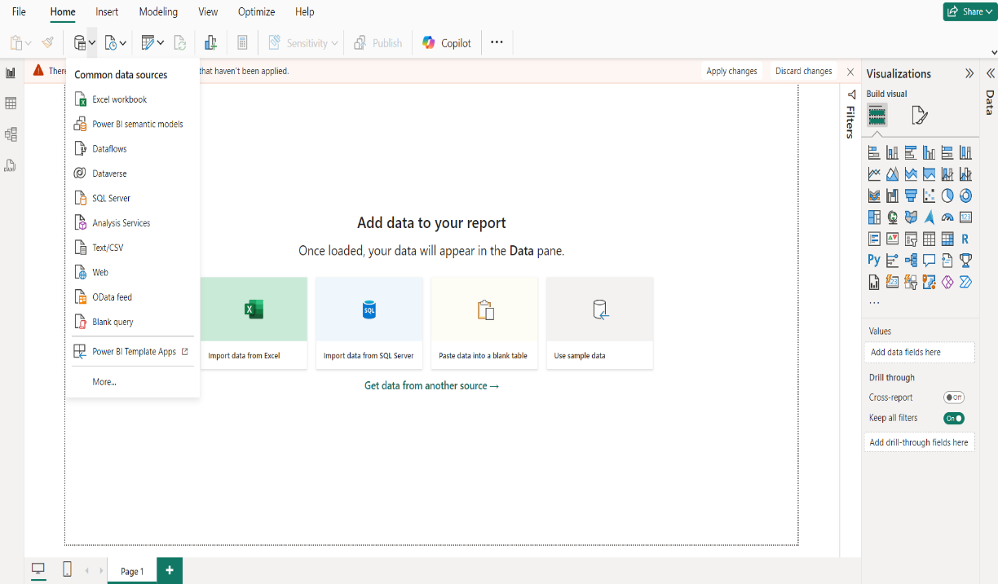

Step 2 :: Import the Exhaustive Analysis of Indian Agriculture.csv from the file manager.

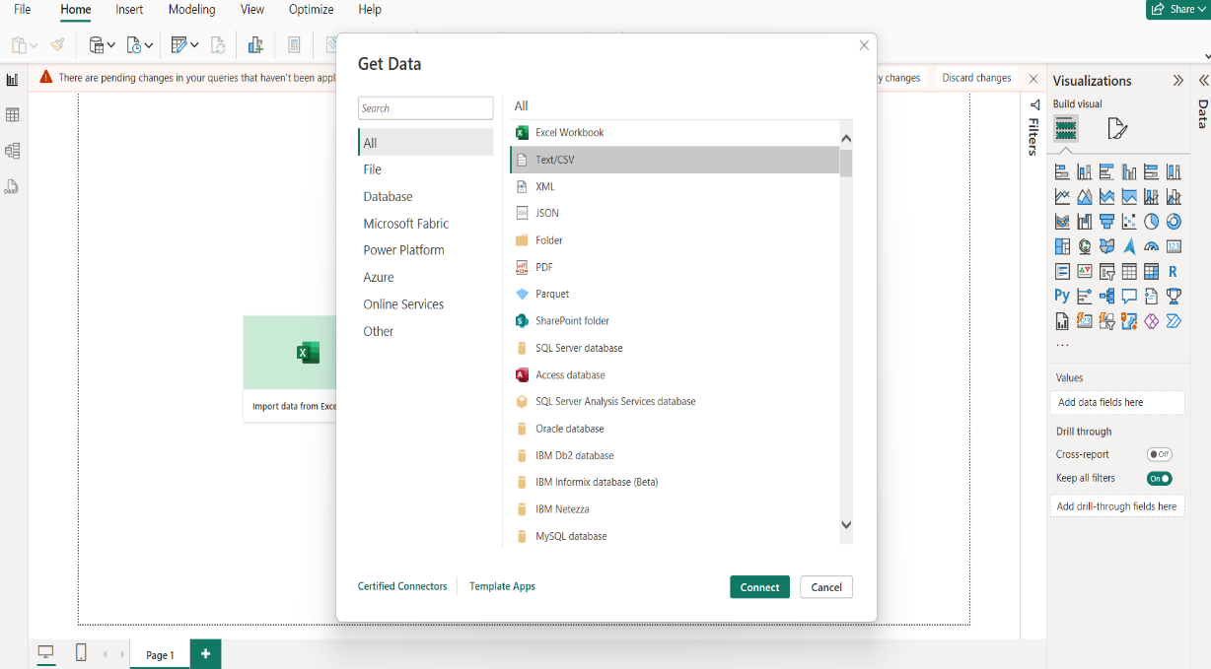

Step 3 :: Now Click on the Transform Data button to Clean the Data.

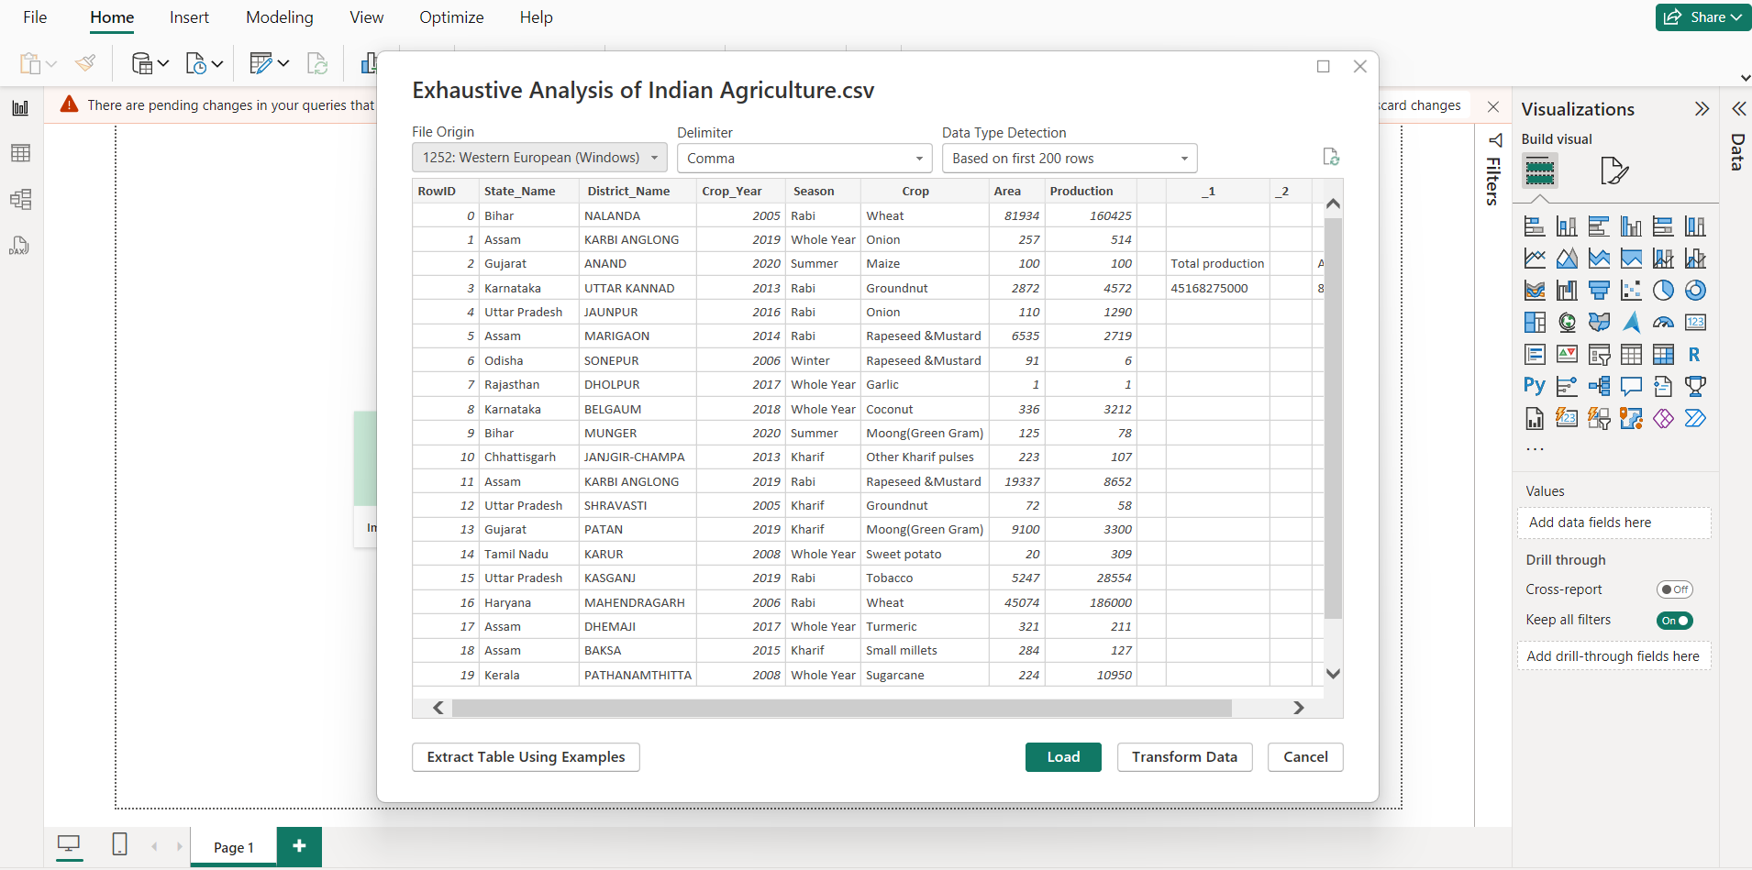

Step 4 :: Remove the Unwanted Columns, Rows, Unknown Values, Blank rows, Null Rows etc. to Clean and Process the Data in the Power Query Editor.

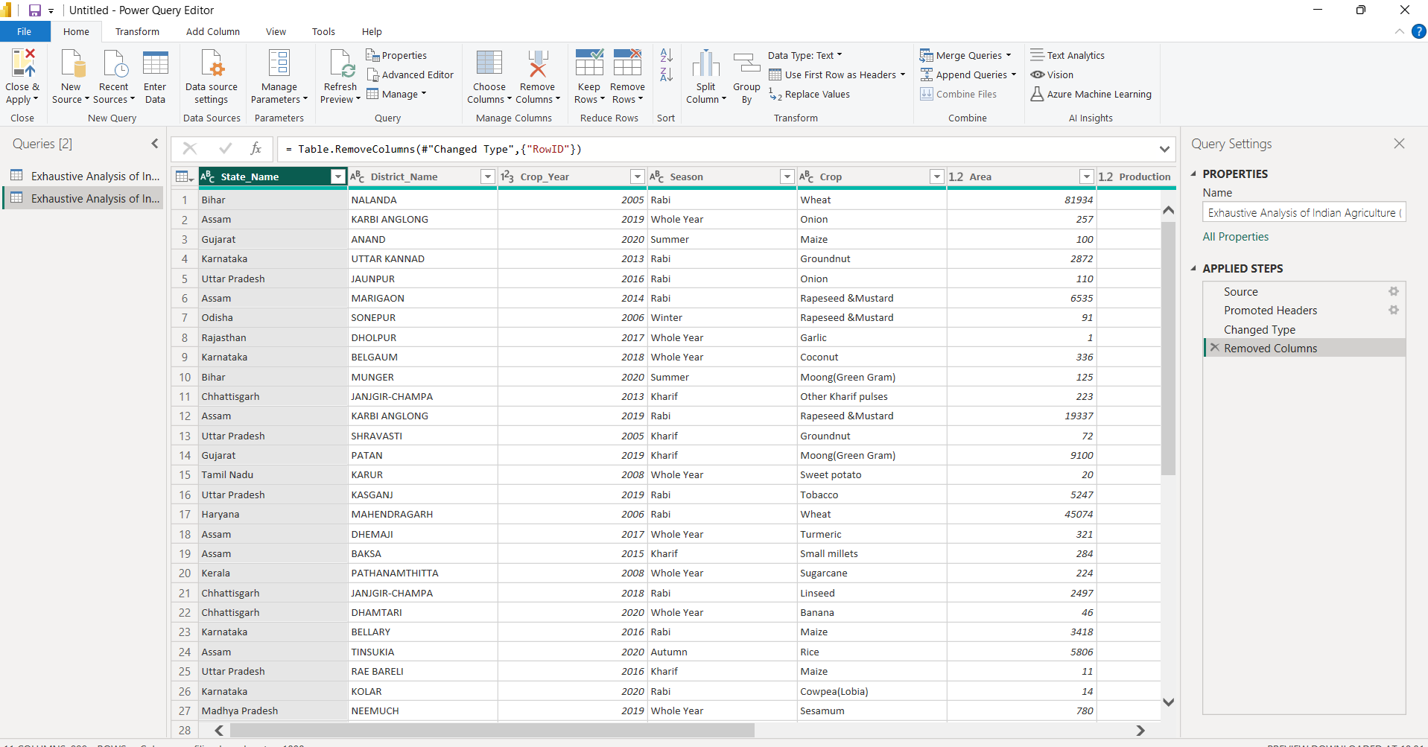

Step 5:: After Performing Cleaning Process , Click On the Close and Apply on the Top Left Corner on the Power Query Editor.

